Submitted by:

1. Zain Ali (2021-uam-1816)
2. Rehman Saeed (2021-uam-1804)

Section:

* BSCS 3(A)

Course Instructor:

* Ms. Javeria Jabeen

**Project Title:**

* Our C++ project based on Store Football player information using stack.
* We use VS code editor to make our project.

**Project Details:**

* If the user chooses to store a player, the program prompts the user for the player's name, age, and position, and then creates a player object with this information. The player object is then pushed onto the stack.
* In program, first we add header file and then include namespace.
* Then initialize a global variable which name is **MAX_PLAYERS**.
* 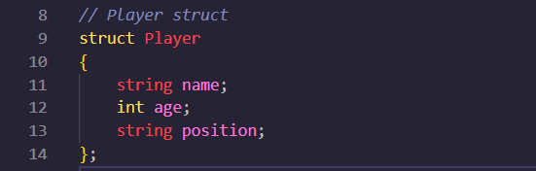Then we create a struct of player object which store player **name**, **age**, and **position** (i.e., ST, CB, RW, LW).

**Stack Class:**

* 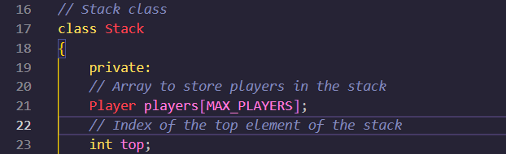In Stack class, we create two private data members. First one is Array to store players in the stack and second one is Index of the top element of the stack.
* In Public, first create a constructor in which we initialize top with -1.
* **Push Function**, the push function takes a single parameter of type Player, which is the player to be added to the stack.
* **Pop Function**, the pop function first checks if the stack is empty by checking if top is equal to -1. If the stack is empty, it prints an error message and returns an empty player object.

If the stack is not empty, the pop function gets the player at the top of the stack by assigning players[top] to a local variable player. It then decrements top to remove the player from the stack and returns the player variable.

* **isEmpty Function**, the isEmpty function takes no parameters and returns a value of type bool, which is true if the stack is empty and false otherwise.
* **deletePlayer Function**, the deletePlayer function takes a single parameter of type string, which is the name of the player to be removed from the stack.
* **Peek Function**, the peek function is a method of the Stack class that returns the top player in the stack without removing it.
* **Print Function**, this function of the Stack class will print the players in the stack.

**Main Function:**

* 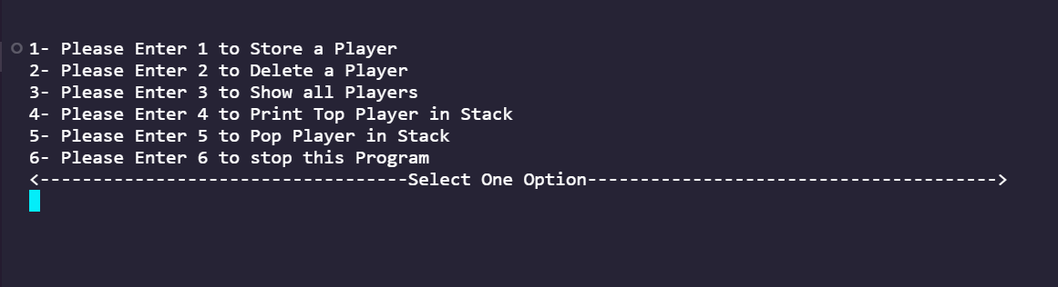In main function for loop is use for show all functions which user want to perform a specific function.

**Output:**

